Flowdiagram ***:***

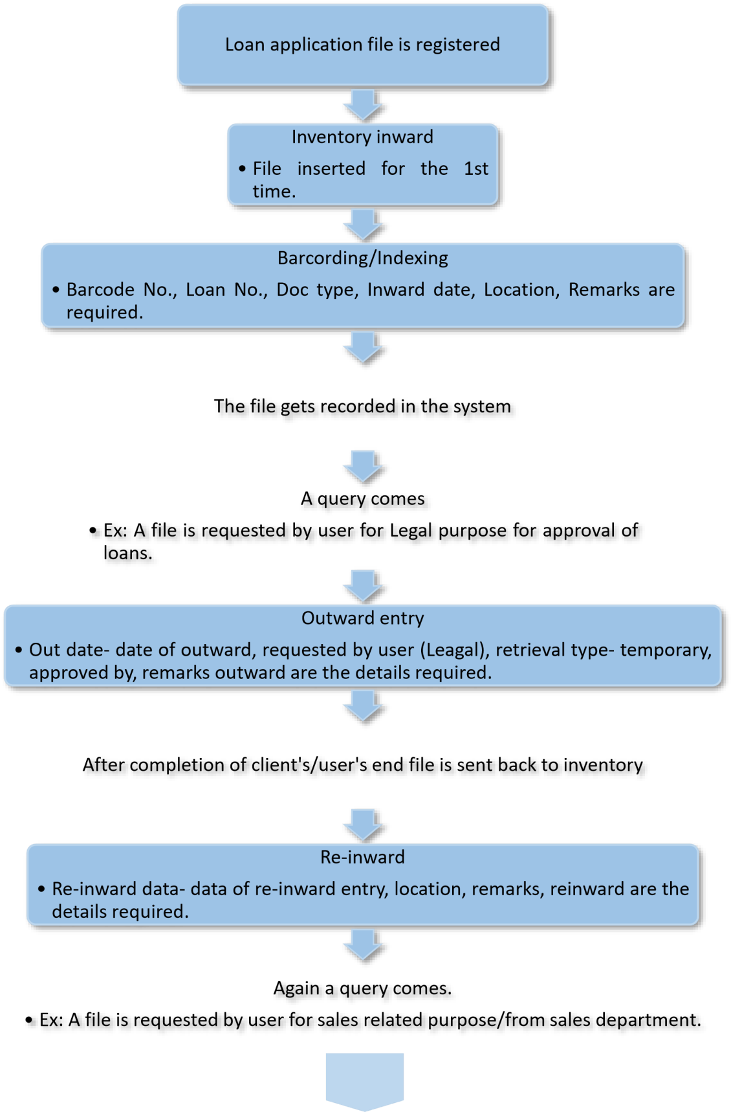

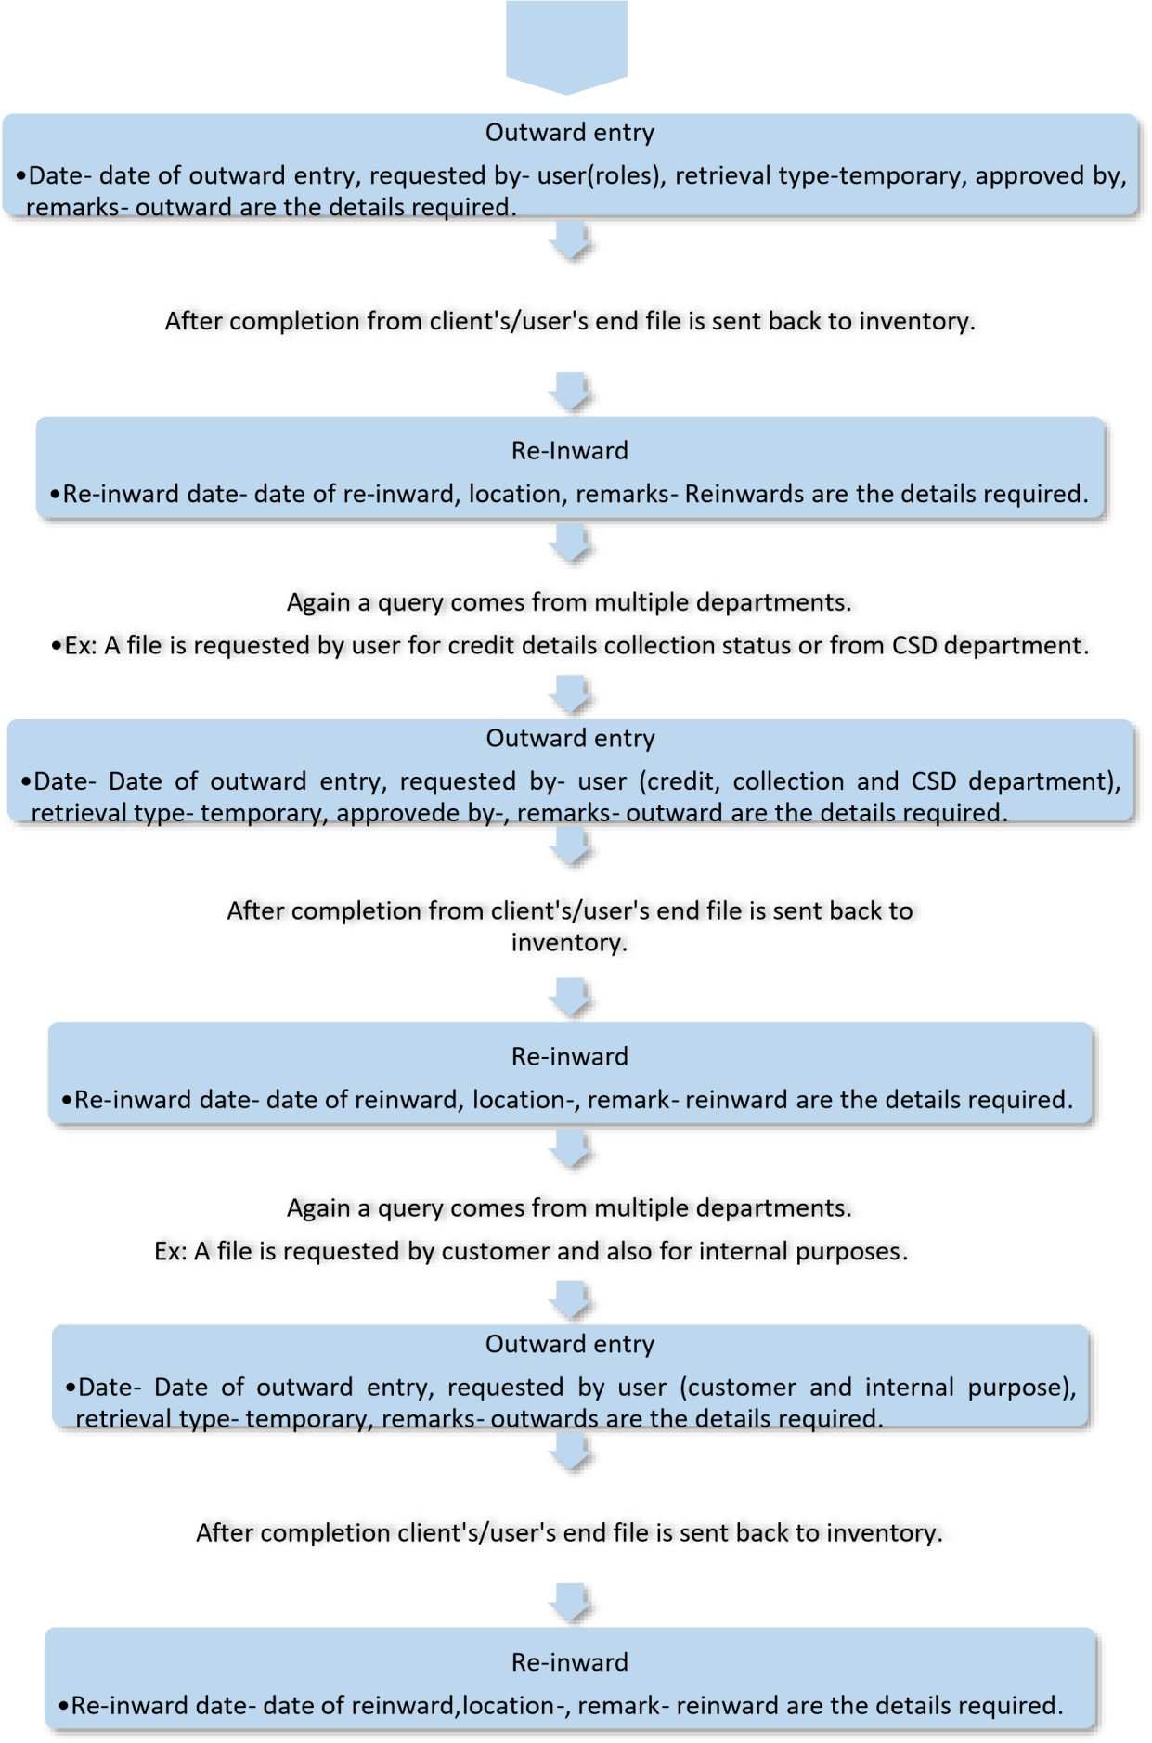

Statement of work

# Problem Statement *-*

## It’s Simple

Much easier than an excel spreadsheet. Manually keying is more hectic. Easy is when the inventory items have a unique barcode label, information can be added to certain items in inventory and associated data can be recalled with one quick and simple scan. Inventory can be viewed in real time, anytime with one scan.

## Barcodes Eliminate Error

Handwriting or manually noting can be a pain; barcoding is a breeze. For every one thousand keystrokes made by a person, there are an average of 10 errors made. However, when using a barcode scanner, only one error is made for every 10 thousand scans. Errors in the front-end eventually mean shipment delays when employees have to search for items that may not be in stock or are misplaced. In addition, data mistakes can cause overspending when too much inventory is ordered.

## Barcodes Provide Security

What business doesn’t want to keep their items and their customers safe? Barcode technology prevents mistakes and mix-ups, which is not just an inconvenience to the end user, but could be harmful too. In addition, barcodes are traceable and fully auditable, promoting theft deterrence, peace of mind, and a demonstrable reduction in loss and liability.

**Inventory Tracking With Barcodes Save Time**

There will be no hectic of physical searching resulting in redemption of time.

# Goals-

* Time consumption- Time is saved rather doing or searching any file manually so that the time saved can be effectively invested in searching other files too.
* Man power redemption- As much of the work is done automatically by the system so less amount of man power required.
* Perfection/Accuracy – Who doesn’t want perfection? With more perfection comes more customer satisfaction hence with perfection as an USP more customers can be ensured.

# Deliverable-

**Breakdown of plan :-**

1. Acquisition of computers
2. Choosing skilled person and providing a short training on working of the barcoding technology.
3. A strong database for storing and tracking of files and also providing security of files.
4. A good management system to coordinate and overcome any upcoming problems.
5. Ultimately aiming to provide a good service to the customers.

# Milestones-

* With good quality service comes more customer satisfaction. Hence, ensuring an increase in the number of trusted customers within a short span of time.
* Aiming of an increase in profit.
* Increase in customers result in enlargement of the client’s business empire in the market.